Module name: Remote control for industrial robot
- Main functionalities:
Remote controlling of industrial robot. This module offers a robot controlling method through Ethernet and update robot joint value to a robot information server. The present GUI as input method is running on specific PC, running GUI on multiple devices will be developed in the future.
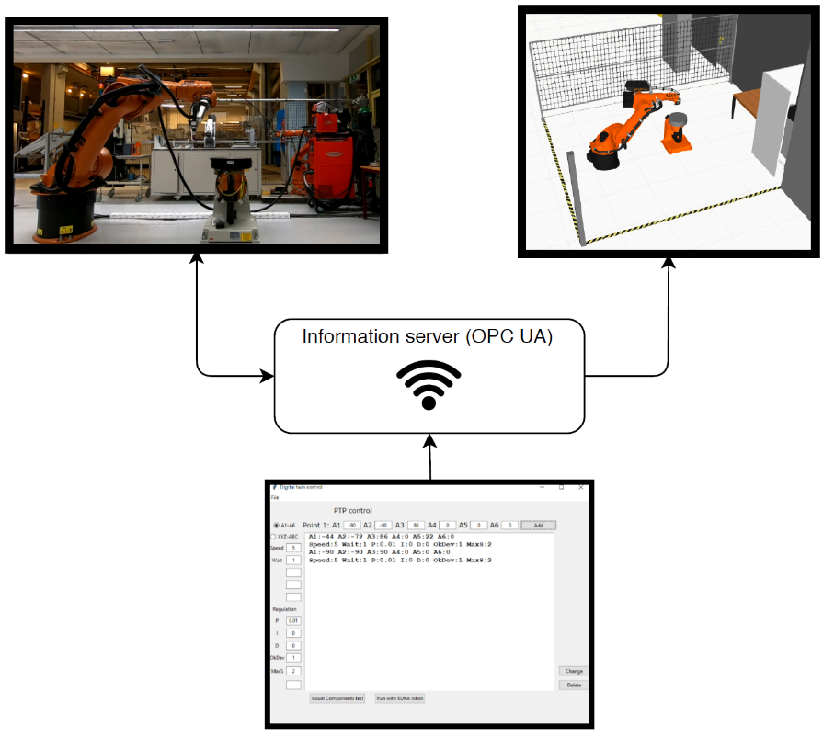
- Technical specifications:
- Hardware: Raspberry Pi, PLC, Industrial robots. Tested with KUKA 30-3 robot with KR C2 controller.
- Software: Open source software (ROS, Movelt, Gazebo, FlexGUI) and Visual Components
- Inputs and outputs:
- Inputs: This module gets input of robot position from robot operator. The robot position can be moving speed with TCP position/6 joint position.
- Outputs: The robot will execute the movements remotely as operator inputted.
- Interface specification:
The interface is still under development, and the full functionality hasn’t been added yet.
Start Page:
In the start page, you can choose what program you want to run, where you can choose the “Simple control” or “Advanced control”. There is a third button for “Welding program” however, this program hasn’t been created yet.
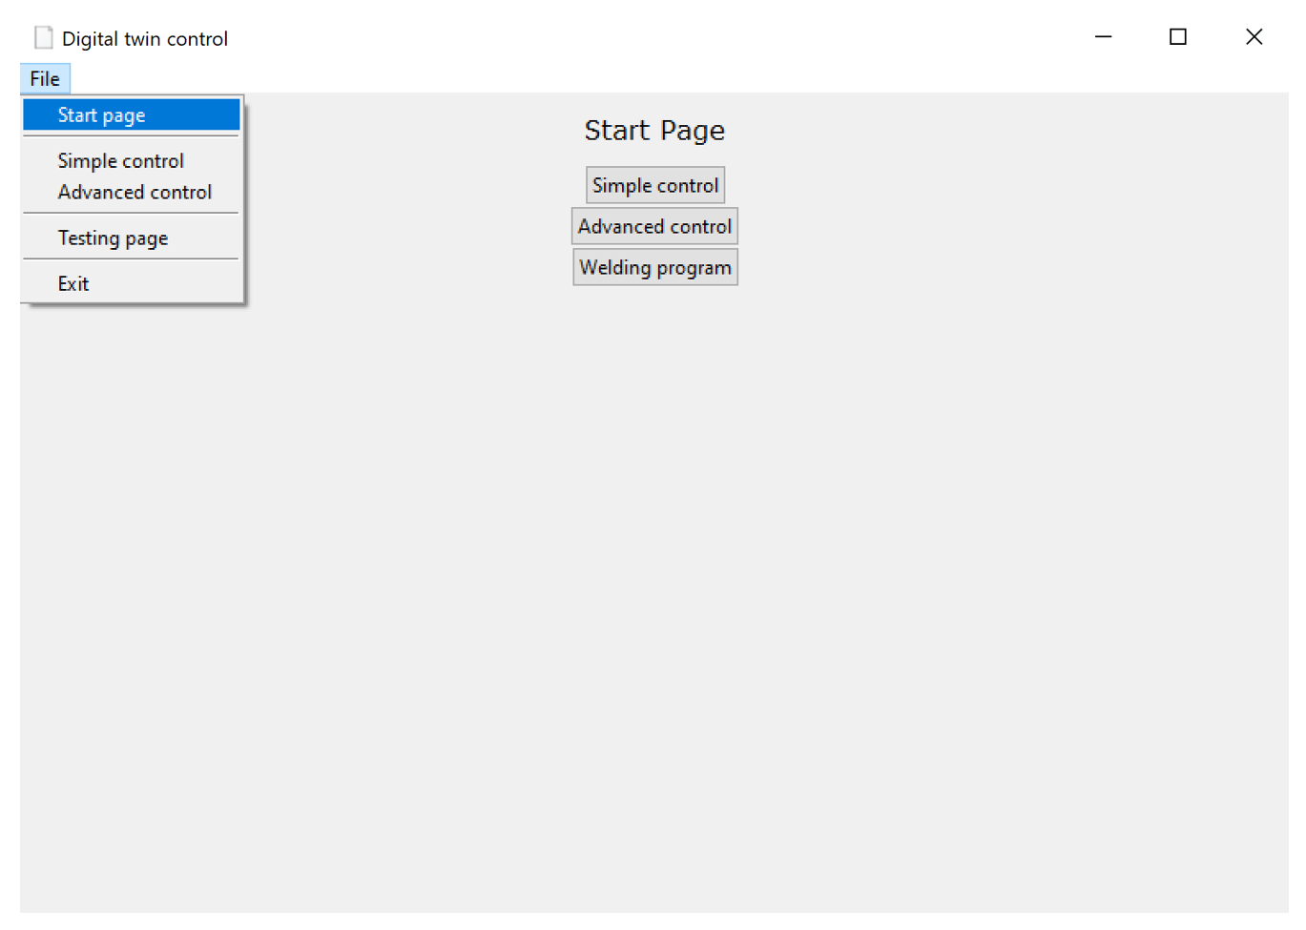
Simple control:
The first control option of the robot is "Simple control". There you can move the robot with either joint control or TCP control, using the buttons shown in the figure. The window with “Increment” is used to choose how fast the robot will move.
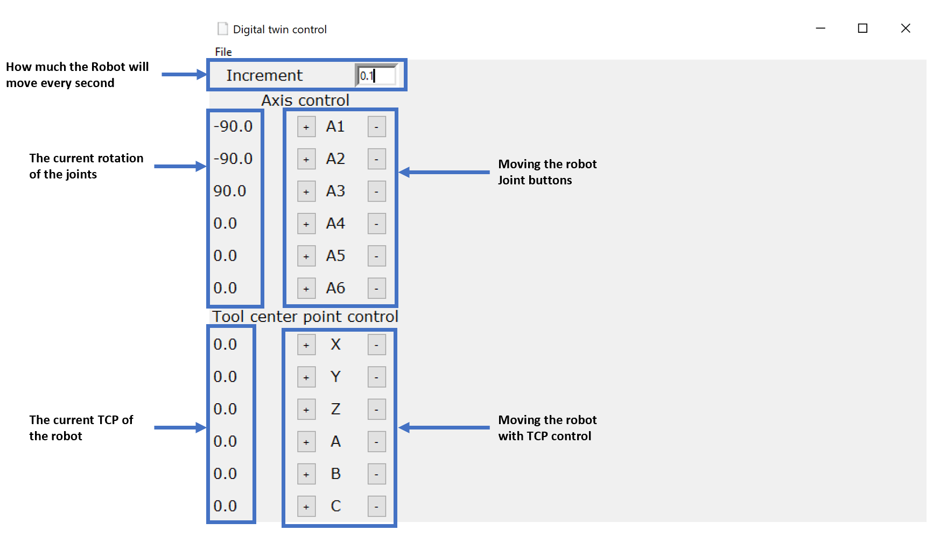
Advanced control:
Advanced control is used for point to point movement of the robot. It is possible to either control the robot with joint control or TCP control and the speed and wait time between each point can be set. The input to the PID control as well as the top speed and acceptable deviation can also be edited.

The "Add" bottom inserts the point where the robot will move and the speed, wait time and PID input to the white window. When all the points have been added you’ll have two options to run the program. The first one is to run a simulation of the program in Visual Components by pressing the “Visual Components test” button. The second option is to run the program with the KUKA robot where Visual Components is used to imitate the robot by pressing the “Run with KUKA robot”. It is possible to edit or delete the point that has been created with the “Delete” and “Change” button.
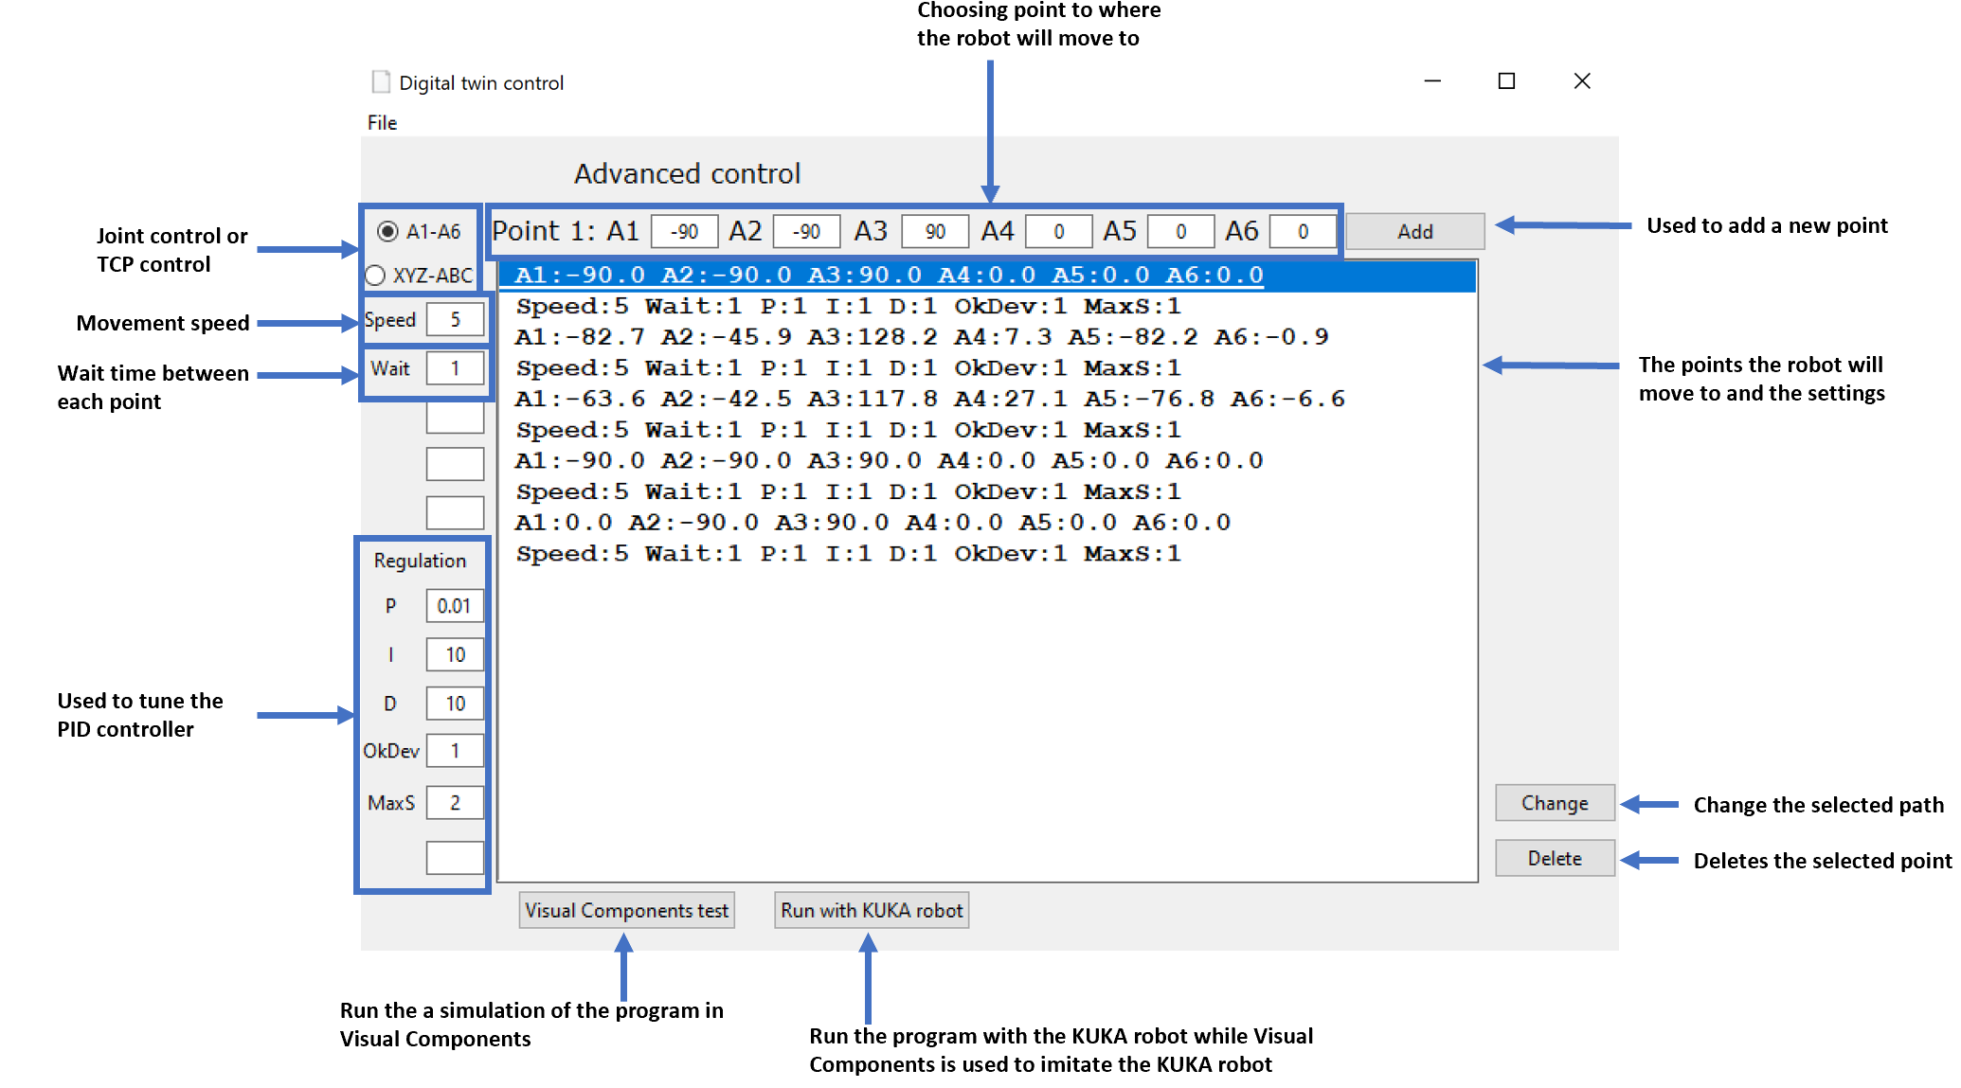

- Formats and standards used:
ROS, Movelt, ISO 10303, OPC UA standard, KUKA RSI
- Availability:
The module with joint control which GUI running on specific PC is available now. The TCP control and running GUI on multiple devices are under development, expected time for readiness of newer version in early 2020.
- Application scenarios:
Remote control of robot.
- Offered for internal / external use
The module is available as a concept for internal and external use.

