Module name: Real-time simulation for industrial robot
- Main functionalities:
The module contains simulated robot/machine which constantly imitate the robot/machine in physical world in real-time. In physical world, the robot joint data and machine state will be updated to a server through Ethernet. In simulation, robot and machine will imitate the physical world by acquiring data from the server.
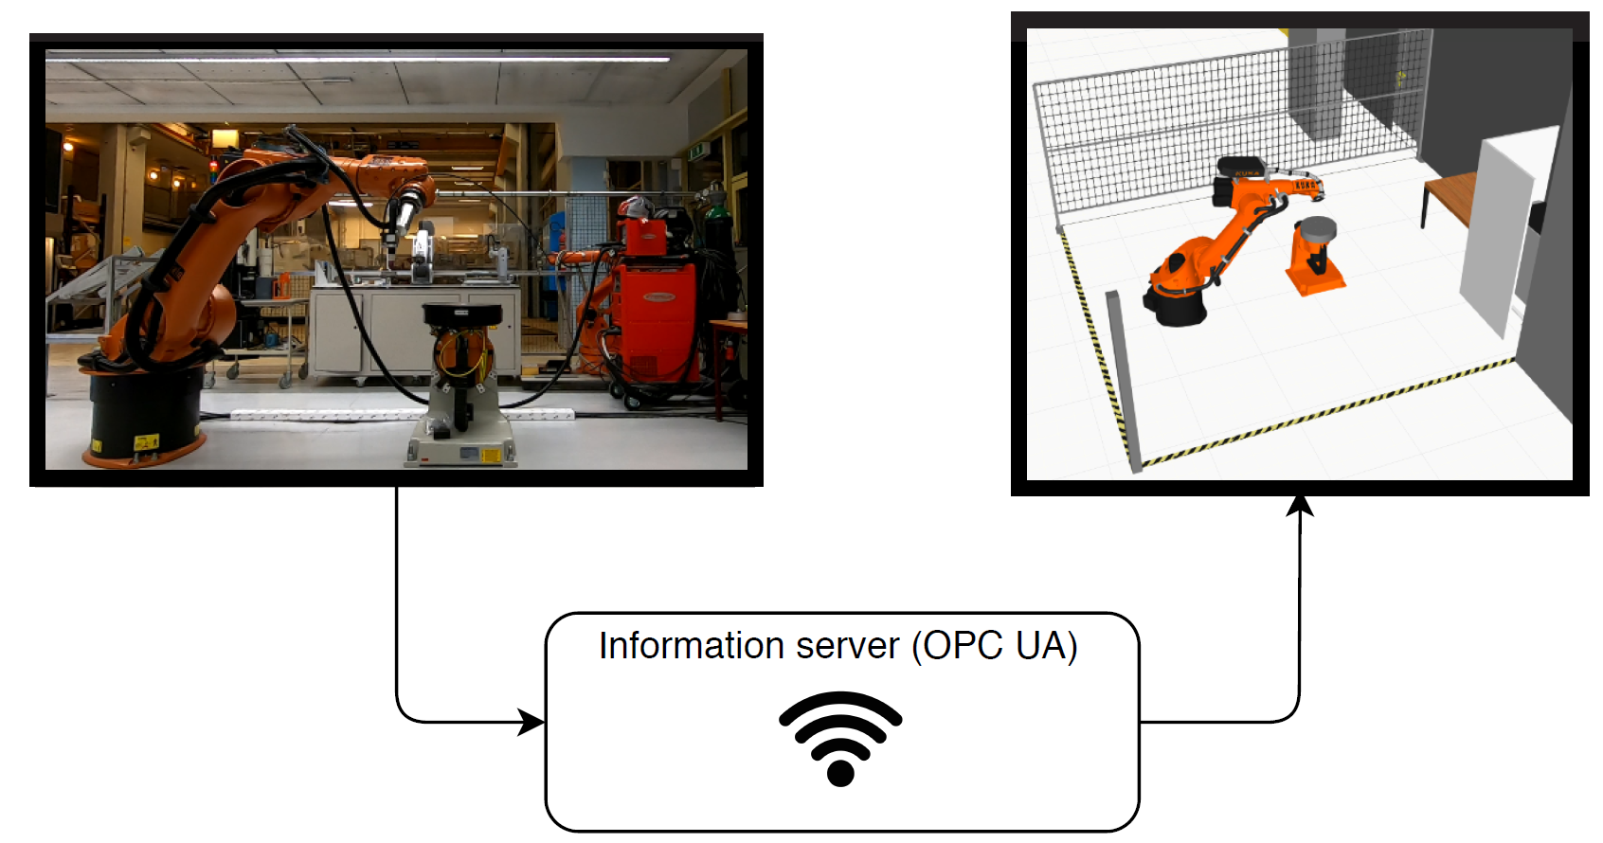
To do analyses on the robot/machine afterward, there will be saved historical data in a CSV file. The data collected can be used for optimization of the program and used to look for errors in the program.
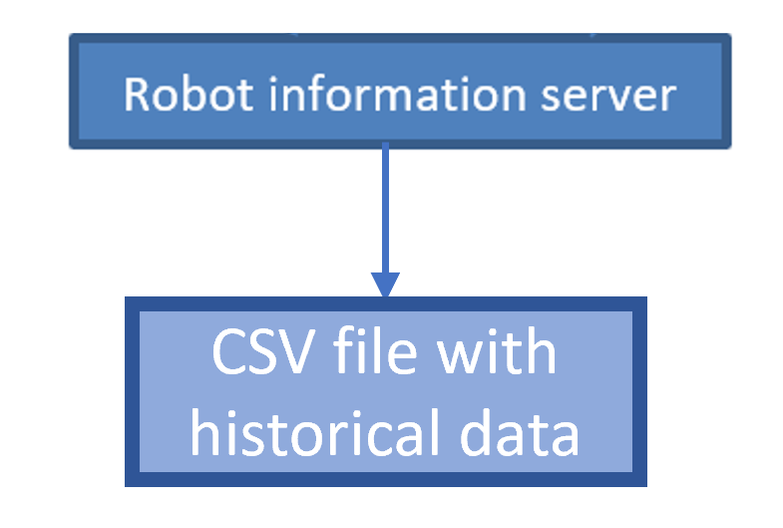

- Technical specifications:
- Hardware: Industrial robots. Tested with KUKA 30-3 robot with KR C2 controller.
- Software: Open source software (ROS, Movelt, Gazebo, FlexGUI) and Visual Components.
- Inputs and outputs:
- Inputs: This module contains a robot information server which need to acquire robot joint value in real-time.
- Outputs: A simulated industrial environment will be presented. Simulated robot /machine will be move according to input value.
- Interface specification:
There are 6 joint values feedback real timely from physical robot to this module. The present application is using KUKA RSI as data feedback method, so the data update speed on the robot information server can be up to every 12ms.
- Formats and standards used:
ROS, Movelt, ISO 10303, OPC UA standard, KUKA RSI
- Availability:
The real-time simulation in Windows system is available now. The newer version with supporting of Linux and Windows is under development and expected time for readiness in early 2020.
- Application scenarios:
Remote monitoring.
- Offered for internal / external use
The module is available as a concept for internal and external use.

